ETT TABLE OF COLORED PART
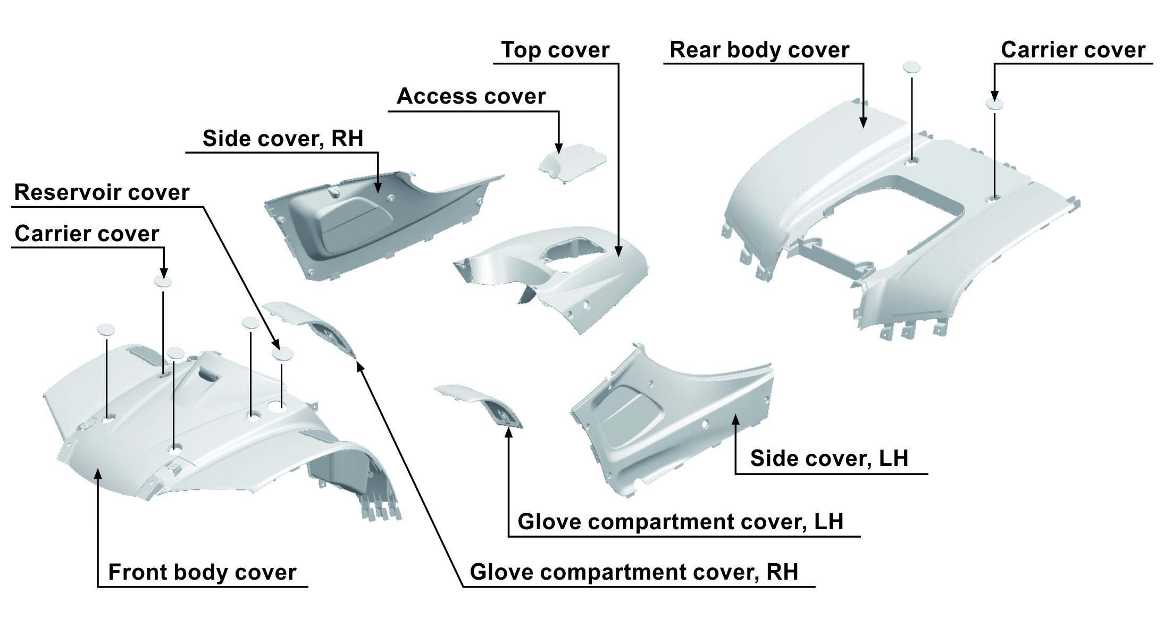

TABLE OF COLORED PART（BLADE 1000 / 1000 EPS）2017
ITEM  NO. | CODE | A | B
ITEM  NO. | Basic Color | Gentry Gray | Pearly Luster Silver
ITEM  NO. | Description | GRA 709 (YG) | SIL 704 (PV)
21 | Front body cover | 512465YG | 512465PV
21 | Glove compartment cover, LH | 512421YG | 512421PV
21 | Glove compartment cover, RH | 512422YG | 512422PV
21 | Carrier cover | 512425YG | 512425PV
21 | Reservoir cover | 512496 | 512496
22 | Access cover | 512592YG | 512592PV
22 | Top cover, With Emblem | 512591YGFF | 512591PVFG
22 | Top cover | 512591YG | 512591PV
22 | Emblem | 518509YG | 518509PV
22 | Emblem | 518512YG | 518512PV
22 | Side cover, LH, With Emblem | 511504FYGLK | 511504FPVLL
22 | Side cover, LH | 511504FYG | 511504FPV
22 | Emblem | 518367 | 518367
22 | Emblem | 518510YG | 518510PV
22 | Emblem | 518511YG | 518511PV
22 | Side cover, RH, With Emblem | 511505YGRK | 511505PVRL
22 | Side cover, RH | 511505YG | 511505PV
22 | Emblem | 518368 | 518368
22 | Emblem | 518513YG | 518513PV
22 | Emblem | 518514YG | 518514PV
23 | Rear body cover | 514498MAYG | 514498MAPV
23 | Carrier cover | 512425YG | 512425PV

I

ETT TABLE OF LABEL 2017

Label | Drawing | Description
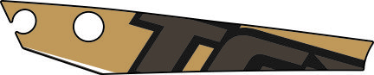 | 518509YG  518509PV | Emblem, top cover.
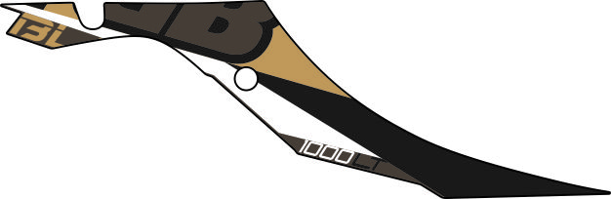 | 518510YG  518510PV | Emblem, Side cover, LH.
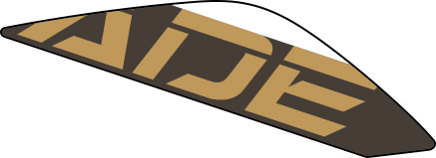 | 518511YG  518511PV | Emblem, Side cover, LH.
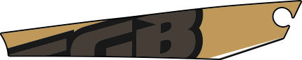 | 518512YG  518512PV | Emblem, top cover.
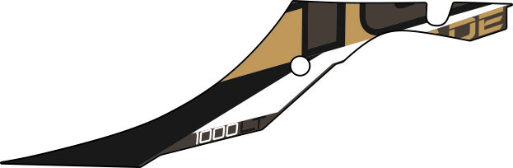 | 518513YG  518513PV | Emblem, Side cover, RH.
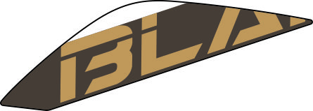 | 518514YG  518514PV | Emblem, Side cover, RH.

I

